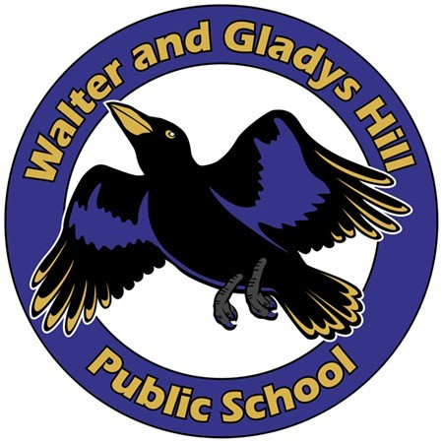Walter and Gladys Hill Public School
School Council Meeting Agenda
Online and in Person @ 6:00 pm
November 1st, 2022

Executive members:

Chair: Shruti Sharma
Vice Chair: Ami Shah
Secretary: Christina Oxamitny
Parent Council Advisor: Swapnil Sharma
Directors at large: Marie McKay, Kriscinda Maki, Chauntelle

Item | Matter | Speaker
1 | Call meeting to Order/Introductions | Shruti Sharma
2 | Review Agenda | Shruti Sharma
3 | Approve September meeting minutes | Shruti Sharma
4 | Principal Report | Mr. Thomas Andrews
5 | Update on Network meeting (October 11th) | Shruti Sharma
6 | Update on “Rally for Public Education” By -The Alberta Teachers’ Association | Shruti Sharma
7 | Meeting adjourned | Shruti Sharma

