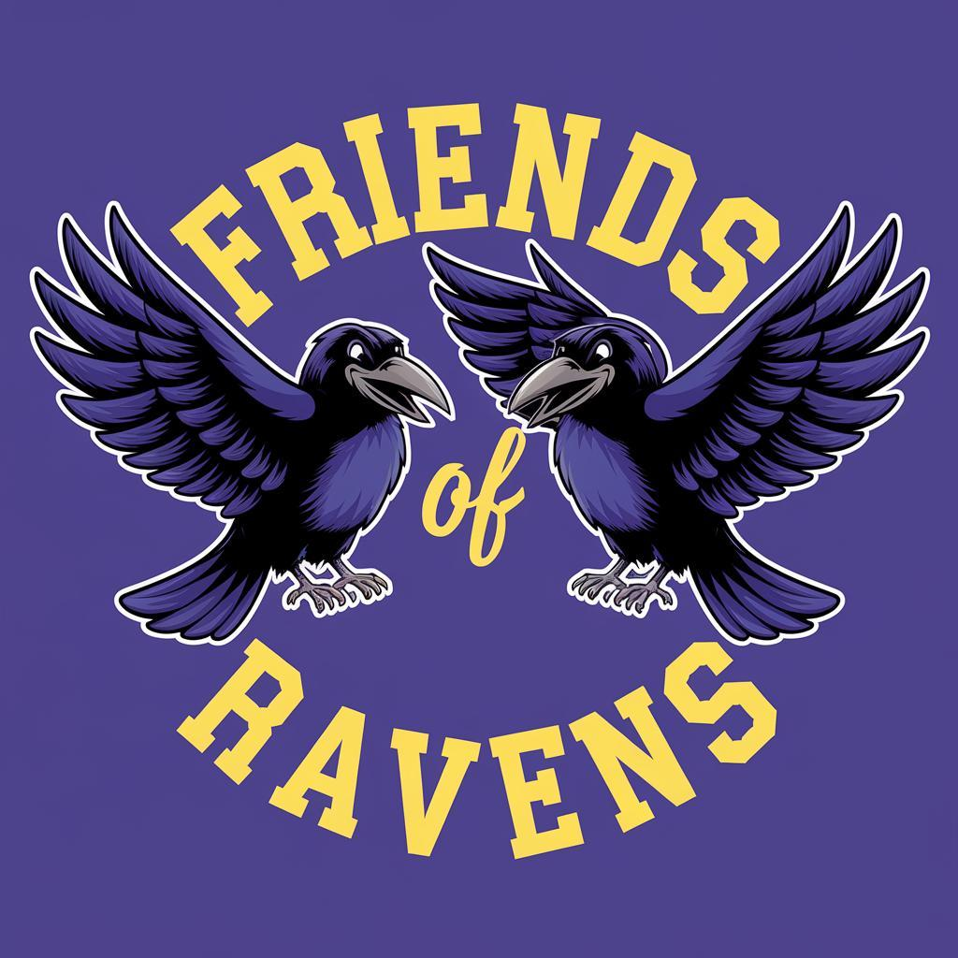**Walter and Gladys Hill**

**Friends of Ravens Society**

**Meeting Minutes**

May 13, 2025

In Person and Virtual Blended Meeting

**Executive Board**

President: Chauntelle McCallum

Vice President: Janet Pardy

Secretary: Amy Hrovat

Treasurer: Marie McKay

Director at Large: Heather Pinsent (Hot lunch Coordinator)

Director at Large: Shruti Sharma (Casino Coordinator)

Director at Large: Kate Buczulak

In Attendance: Jihan Jones, Janet Pardy, Marie McKay, Shruti Sharma, Chauntelle McCallum, and Calvin.

|  | **Item** | **Presentor** |
| --- | --- | --- |
| 1 | Call meeting to order 6:46  Motions: Janet  Seconds: Amy | Chauntelle McCallum |
| 2 | Review Agenda  Motion Approve: Amy  Seconds: Marie | Chauntelle McCallum |
| 3 | Review and Approve meeting minutes from April 9 2025  Motions: Janet, pending change to butterfly purchase being from AGLC account (change reflected on minutes)  Seconds: Jihan | Chauntelle McCallum |
| 4 | Financial update   * Account Update * Primary $12 300 * Hot lunch $29 500 * AGLC $29 400   Casino Fundraiser $32,500 Approximately  Awaiting tip amount:  Requests   1. Cricut Machine $350 for Main Office   Motion to Approve: Janet  Second: Chauntelle | Marie McKay |
| 5 | Hot Lunch Update   * D Spot will be removed from rotation due to 2 previous cancellations | Heather Pinsent via Marie |
| 6 | Current Business   * Movie Night May 23 - changed to September welcome back movie night * 10 Year T-Shirts | Chauntelle McCallum Shruti Sharma |
| 7 | New Business   * Calendar magnets   400 calendars last year was $650 approve up to $800  Motion: Chauntelle  Second: Jihan  250 Reflective Items for up to $400  Motion: Chauntelle  Second: Jihan | Chauntelle McCallum |
| 8 | Meeting Adjourned - 7:19 pm  Motions: Chauntelle  Seconds: Amy | Chauntelle McCallum |